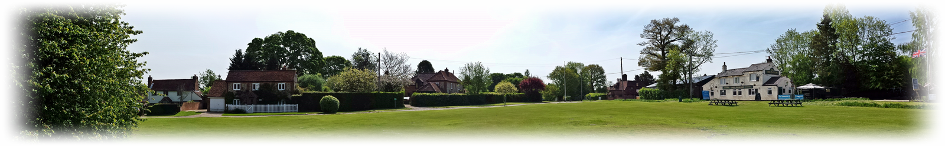
HYDE HEATH VILLAGE SOCIETY

Your opinion matters

MEMBERSHIP APPLICATION

Name(s)----------------------------------------------------------- --------------------------------------------

Address-----------------------------------------------------------------------------------------------------------

Telephone Number ------------------------------------------

Email address -------------------------------------------

I/we apply for membership of Hyde Heath Village Society and enclose our one off payment of £10 by cheque payable to Hyde Heath Village Society. If you prefer paying electronically just let us know and we will send you our account details.

Areas of interest or concern to me/us with regard to the future of Hyde Heath include

………………………………………………………………………………………………………

………………………………………………………………………………………………………

Please complete and email to membership@hhvs.org.uk or send Membership form and cheque payable to “Hyde Heath Village Society” to Steven Bates, Brays Farm, Keepers Lane, Hyde Heath, HP6 5RJ

